1.
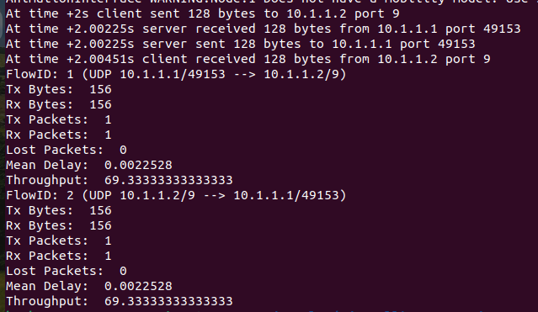

2.
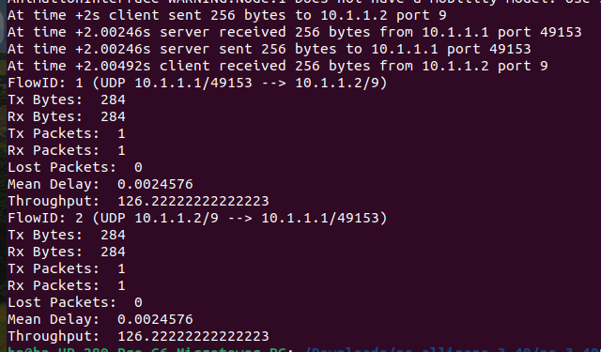

3.
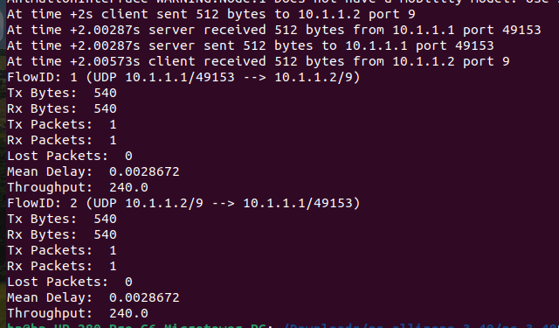

4.
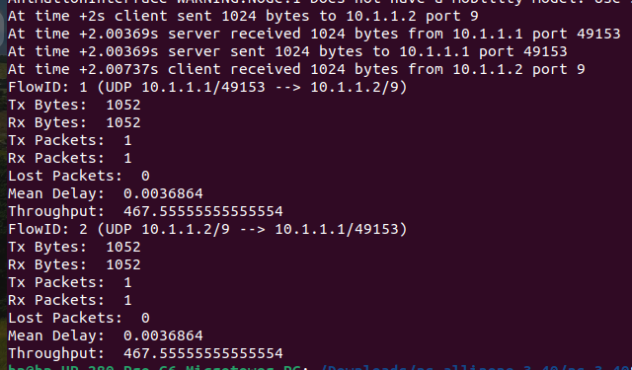

5.
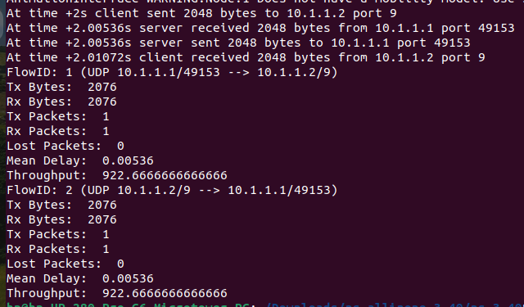

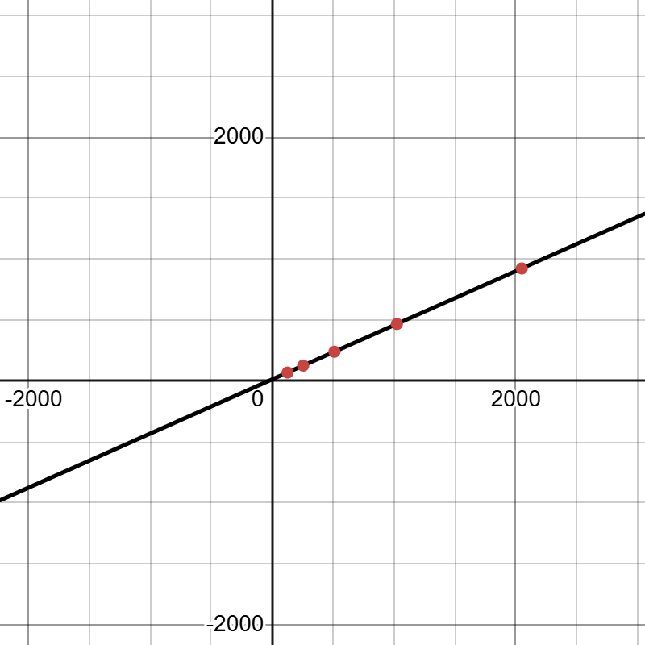

The graph illustrates the relationship between data size and throughput. The x-axis represents data sizes ranging from 128 to 2048, while the y-axis indicates the corresponding throughput. Overall, the graph shows a clear linear and increasing pattern, suggesting that as data size grows, throughput rises proportionally. This increase occurs because larger data sizes enable more efficient data transfer by reducing overhead and improving performance. The upward-sloping line reflects a strong and consistent positive correlation between data size and throughput.

